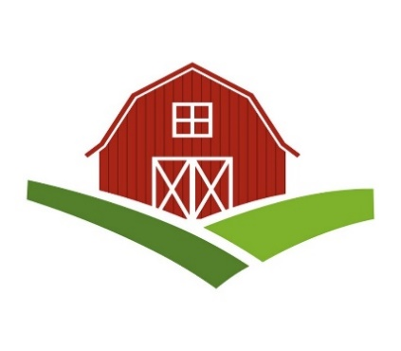
Chatt Hills Barn Quilt Trail
Application

Thank you for your interest in the Chatt Hills Barn Quilt Trail.
WHAT IS THE BARN QUILT TRAIL?
The Chatt Hills Barn Quilt Trail is a community art project designed to celebrate the rural heritage of Chattahoochee Hills, Georgia. It features a collection of colorful quilt squares painted on large sign boards (4x4 or 8x8) affixed to barns, outbuildings, homes, or businesses. A map shows the location of these barn quilts along the trail and points visitors to the website where heritage information is provided for each location and quilt.
The Barn Quilt Trail movement began in 2001, when Donna Sue Groves, a field representative for the Ohio Arts Council, decided that she wanted a quilt square painted on her barn to honor her mother, a lifelong quilter. She shared her idea with friends, and together they decided that if they were going to paint one quilt square, they might as well paint twenty and create a driving tour to attract tourists to their rural community. Today, there are more than 9,000 barn quilts organized into 120 quilt trails in 49 states, making this one of the fastest- growing grassroots public art movements in the United States.
HOW TO JOIN THE TRAIL
We invite anyone in Chattahoochee Hills to join the barn quilt trail. All they need is a barn or building that can easily be seen from a public road. They also need to be OK with the visitors taking photos of the barn quilt from the public roads, and we would like the barn quilts to be displayed for a period of two years.
Hosts who meet the above requirements have three options for creating a barn quilt:
- If they already have a barn quilt on their property, they may join the trail.
- If they would like to create their own barn quilt, they may either pay for their own barn quilt or they may receive a free barn quilt through our lease agreement.
- If they would like a barn quilt created for them, a volunteer will help with the selection of a quilt pattern and then paint and install the barn quilt through our lease agreement.
To join the trail, please complete the application on the following pages.
ABOUT THE LEASE AGREEMENT
The Chatt Hills Barn Quilt Trail is eligible for funding through the City’s hotel/motel tax funds, since a portion of these funds must be spent on specific tourism projects. Through the City’s Lease Agreement, the barn quilt is leased to the owner at no cost through the 24-month duration of the project. At the end of the agreement, the City will either remove the barn quilt, or the owner may purchase and keep the barn quilt for $25.

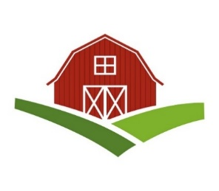
Chatt Hills Barn Quilt Trail
Application

APPLICANT’S INFORMATION
Date of Request: |  | Name:
Phone: |  | Email:
Mailing Address:

TYPE OF REQUEST
- I have an existing barn quilt and want to join the trail.
- I want to make my own barn quilt.
- I will pay for my own barn quilt.
- I will use the City’s lease agreement to receive a free barn quilt.
- I want a barn quilt created for me through the City’s lease agreement.

SITE INFORMATION
Owner (If different than applicant): |  | Name:
Phone: |  | Email:
Site Location:
Site Description:
Site History:
Note: Sites may include barns, outdoor buildings, homes, or businesses. The site must be visible from a public road and/or be accessible to the public during clearly posted hours.
QUILT BLOCK INFORMATION
Pattern Name:
Colors:
Do you need assistance selecting a pattern? |  | YES |  | NO
Note: Quilt blocks must be based on traditional quilt patterns. The designs cannot include: initials, words, advertising, sports team, religious, or organizational symbols, because it would then be considered a “sign” and not “art.”
Chatt Hills Barn Quilt Trail
Application

AGREEMENT
- I agree that my design will be based on traditional quilting patterns and that all barn quilt blocks are reviewed by a committee for quality and conformity to established standards.
- I agree that the barn quilts are a form of public art and should not be construed or considered as advertising.
- I agree that all barn quilts that are provided free of charge remain the property of the City of Chattahoochee Hills.
- I agree to keep the barn/building and nearby area neat and free of debris.
- I agree that in order to be a part of the Quilt Trail my painted barn quilt must be easily visible from a public road.
- I understand that travelers may be stopping to take pictures of my barn and, at times, pull onto my property.
- I agree that it is my responsibility to post any notices limiting or restricting public access to my property, such as: PRIVATE—ENJOY FROM ROAD, VISIT AS POSTED, VISIT DURING SET BUSINESS HOURS, etc.
- I agree to notify the Chatt Hills Barn Quilt Trail committee if I rent, lease, sell, or otherwise convey my property, or if I remove the quilt block from the building.
- I agree to give permission for my barn quilt block and the building & property it is on to be used in the promotion of the Quilt Trail. This includes any websites, social media, traditional media, brochures, maps, etc. that are maintained or published by the Chatt Hills Barn Quilt Trail. I also understand that any promotion is subject to publication deadlines, and there is no guarantee that my barn quilt block will be included.
- I agree to indemnify and hold harmless the Chatt Hills Barn Quilt Trail Committee and the City of Chattahoochee Hills including their officers, agents, and employees for and against any and all claims, liabilities, losses, and causes of action related to the Chatt Hills Barn Quilt project.

Signature of Applicant: |  | Date:
Signature of Committee Member: |  | Date:
RETURN YOUR APPLICATION TO:
Laurie Searle via email: Lsearle@bellsouth.net or to the following address:
Laurie Searle, 12600 Whiteside Rd, Chatt Hills, GA 30268
FOR COMMITTEE USE ONLY
Date Received:
Quilt Pattern Approved:
Quilt Location Approved:
Installation Date:
GPS location for Quilt Trail Map

