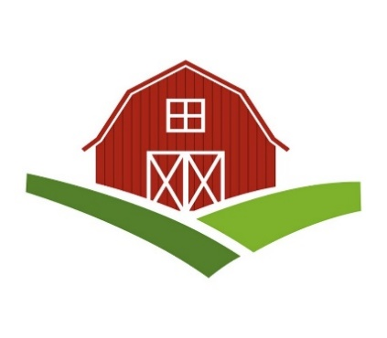
Chatt Hills Barn Quilt Trail
Policies and Procedures

INTRODUCTION
The Chatt Hills Barn Quilt Trail is a volunteer public arts project intended to promote agritourism and community pride by honoring our rural heritage. It will create a series of painted quilt designs called barn quilts, placed on barns, structures, and buildings around town, so as to create a walking or driving trail.
While any citizen may create a barn quilt for personal use on their property, participation in this project requires adherence to a set of standards, since the Chatt Hills Barn Quilt Trail will be intentionally attracting tourists, and as a byproduct, representing our City.
The purpose of this document is to outline policies and procedures to ensure a high-level of quality for this art project, including:
- Artistic standards
- Production standards
- Design review/approval process
- Qualifications for host locations
- Who creates and owns the barn quilts?
- Funding /reimbursement policies
- Waiver of liability
ARTISTIC STANDARDS
The Chatt Hills Barn Quilt Trail shall meet the following artistic standards:
- Only traditional or contemporary quilt block designs in the public domain may be used.
- The quilt block design should not be repeated on the trail.
- Quilt blocks cannot include letters, words, logos, or images that covey a message, as those items would classify the project as a sign under the City’s zoning.
DESIGN/REVIEW PROCESS
A design/review committee shall be formed to approve the design and color selections of the barn quilts, so that they do not duplicate other barn quilts on the trail. It is suggested that:
- Committee members include artists, quilters, crafters, and someone with construction skills.
- If any of the project’s funding comes from the City of Chattahoochee Hills, the City Manager and/or Mayor sign-off on all designs.
- If the Committee would like a barn quilt placed on city-owned property, it must submit a proposal with the design to the City Council.
- If a stand-alone quilt block is requested, the request be reviewed and authorized by the City’s Community Development Department.
- The Committee shall give preference to the applicant’s first design choice. If that design is already on the quilt trail, the committee can assist in finding a similar – but different – design.
PRODUCTION STANDARDS
The Chatt Hills Barn Quilt Trail has adopted the following production standards to ensure the quality, consistency, and the longevity of these beautiful pieces of art:
- Aluminum Composite Sheets shall be used as the painting surface for the barn quilts, due to its durability, smooth painting surface, and its light weight, which facilitates easier installations.
- Standard barn quilt sizes shall be 4’x4’ or 8’x8’, which accommodates both large barns and buildings and smaller outbuildings, while providing economy of use in the standard 4’x8’ composite aluminum sheets.
- Custom barn quilt sizes will be considered upon request.
QUALIFICATIONS FOR HOST PROPERTIES
- Barn Quits may be placed on barns, outbuildings, businesses, homes, or other structures.
- Host structures must be well kept and close to the road with an unobstructed view.
- Hosts must agree to keep their barn quilt maintained.
- Hosts must agree to notify the Committee if they sell the property, remove the barn quilt, or if the barn quilt becomes damaged beyond repair.
- Hosts agree to allow tourists to stop and take photos along the public roads.
- Hosts agree to allow their barn quilt and structure to be used in promotional materials.
- Hosts agree to be responsible for the installation of their barn quilt or sign a waiver of liability if volunteers assist.
- Hosts must complete the Chatt Hills Barn Quilt Applications.
- Hosts must sign the City’s Lease Agreement, if their barn quilt is funded by the City.
WHO CREATES AND OWNS THE BARN QUILTS?
As a grassroots art project, the Chatt Hills Barn Quilt Trail encourage citizen participation and will recruit hosts and volunteers to paint the barn quilts. If a citizen pays for their own barn quilt, they own the barn quilt. If the barn quilt is paid for by the City, the City retains ownership of the barn quilt through its Leasing Agreement.
FUNDING AND REIMBURSEMENT POLCIES
The City has agreed to fund this project though hotel/motel tax revenue as a tourism project. Estimated cost for a barn quilt sized 8x8 ft is $300 ($150 for sign board, $150 for paint & supplies). Cost for up to 15 barn quilts is $4,500. Additional costs for promotions, potentially including a tourism brochure and celebration event, will be submitted as a proposal for the City’s approval. The Committee will adhere to the reimbursement policies as set by the City.

LEASING AGREEMENT
The City has developed a Leasing Agreement, for all barn quilts paid for by the City. It specifies that the barn quilt remains the property of the City until the end of the Agreement, at which time the property owners have the option of having the barn quilt removed or they pay purchase the barn quilt under the terms of the Agreement. The Agreement also includes requirements for maintaining the barn quilt, as well as a waiver of Liability.

APPLICATION
The Chatt Hills Barn Quilt Trail has created an Application for participation in this project. Hosts are encouraged to complete the application, located on the website.

WEBSITE: http://www.chatthillsbarnquilttrail.com

